**Tools and s/w needed for creating angular project**

Install the angular cli by typing the below command in command prompt, for below command to work you first need to have npm(node package manager installed)



Now we will create angular project by executing the below command



Once the project(DatingApp-SPA) is created it will create the below structure

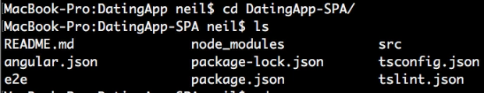

Below Command is used to run the angular project through command prompt(angular CLI)



## **Additional extensions used for Angular project to make the angular development easier and faster**

1- Angular V6 snippets

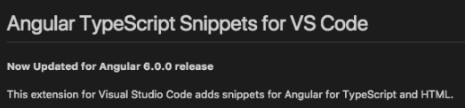

2- Angular Files

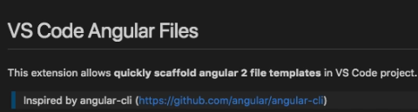

3- Angular Language service

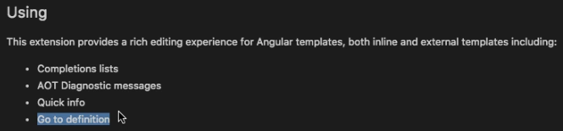

4- angular2-switcher

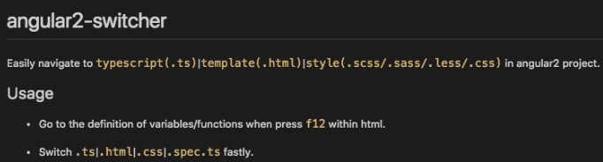

5- Auto rename tag

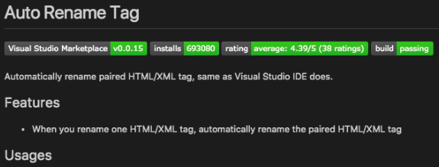

6- Bracket pair colorizer

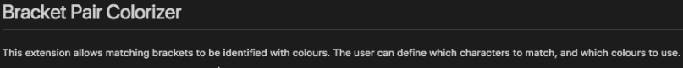

7- Debugger for chrome

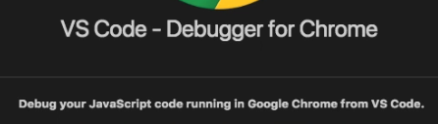

8- Material Icon theme

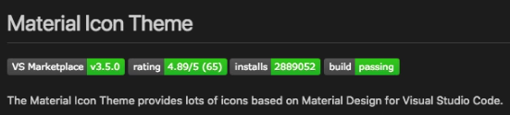

9- Path Intellisense

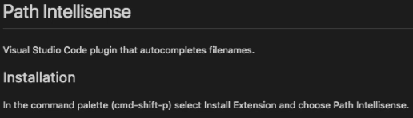

10- Prettier - code formatter

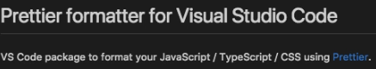

11- TSLint

